***LAB MANUAL # 6:***

***Roll_no 068464***

***Submitted _by Nabila Naz***

***Submitted To Sir Kamran .***

***Bs (IT) 5th(sem) Morning***

**CC-311 Operating Systems LAB**

***“Create Threads in Linux”***

**Q1**. Write a program to create two Threads T1 and T2. Thread T1 creates

a file named Thread.txt while T2 writes “Hello its T2” into the

Thread.txt

**(Figure 1)**

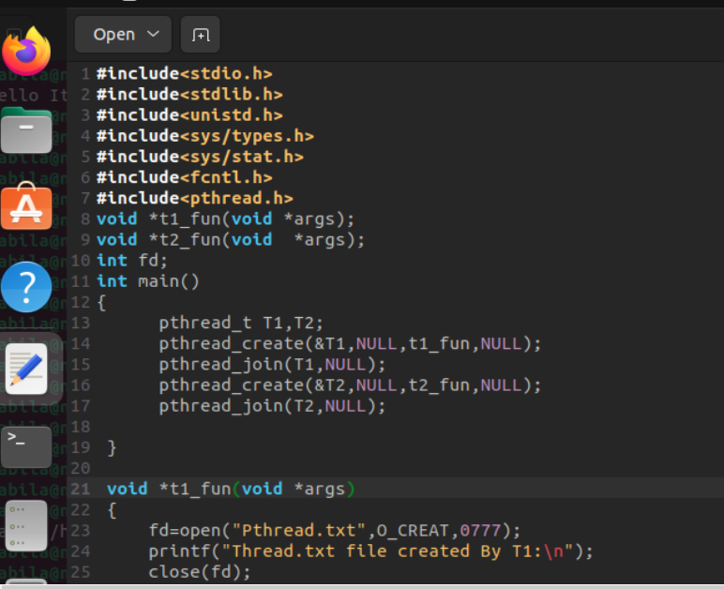

**(Figure 2)**

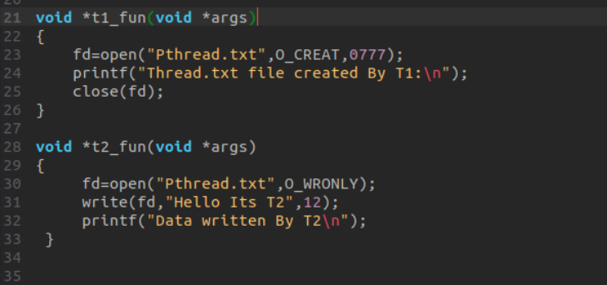

**Compilation:**

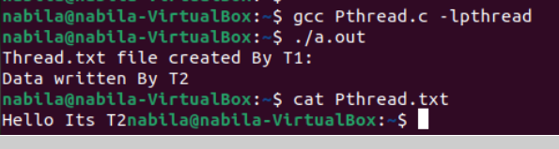

**Q2.** Write a program to create a thread T1. The main process passes two

numbers to T1. T1 calculates the sum of these numbers and returns the

sum to the parent process for printing.

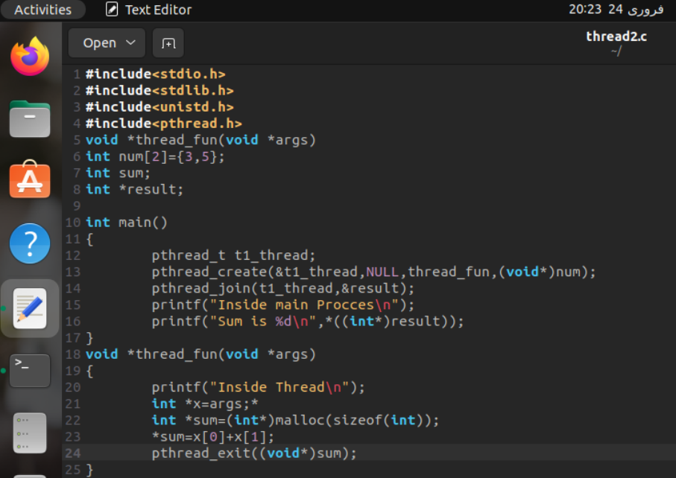

**compilation**



***Viva Questions:***

**Q1. Why is the second parameter in pthread_create() function generally taken as NULL?**

The second parameter In pthread_create() is typically used to set thread attributes, but it is often set to NULL when the default attributes are sufficient for the application. If you need to specify attributes, you can create a pthread_attr_t object and pass it as the second parameter.

**Q2. What is the significance of using pthread_join() function?**

The pthread_join() function is used to make the main thread wait for the specified thread to finish its execution. This ensures that the resources associated with the thread are properly cleaned up before the program exits.

**Q3. Which function is used to return some value from the child process to the parent process?**

The pthread_exit() function is used to return a value from the thread. The argument passed to pthread_exit() is the value that will be returned to the joining thread when the thread completes its execution.

**Q4. How can we pass multiple values to a thread?**

To pass multiple values to a thread, you can create a struct that contains all the values you want to pass. Then, pass a pointer to an instance of this struct as the argument to the thread function.

**Example**

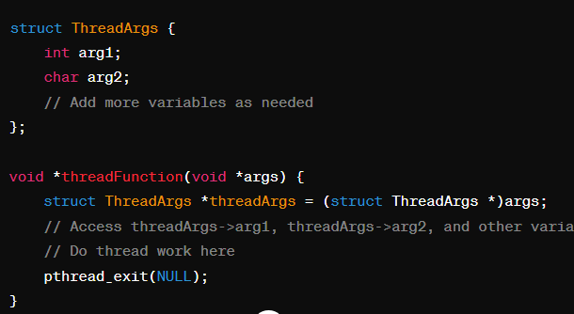

**Q5. How is the value returned by a thread saved/stored by the main process?**

The value returned by a thread via pthread_exit() can be retrieved by the main process using the pthread_join() function. The second parameter of pthread_join() is a pointer to a location where the return value of the thread will be stored.

**Example:**

